#### 

**Artificial Intelligence**

**Lab 01**

**Name: Alishba Waqar**

**Sap ID: 46997**

**Batch:** BSCS-6th semester

**Task 01:**

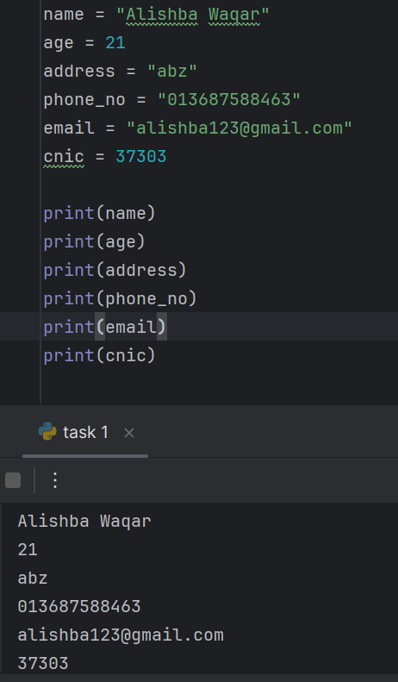

**Task 02:**

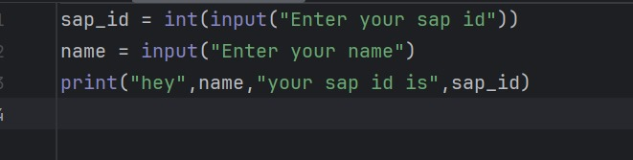

**Output:**

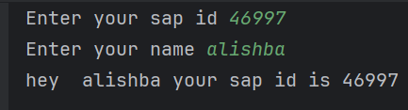

**Task 03:**

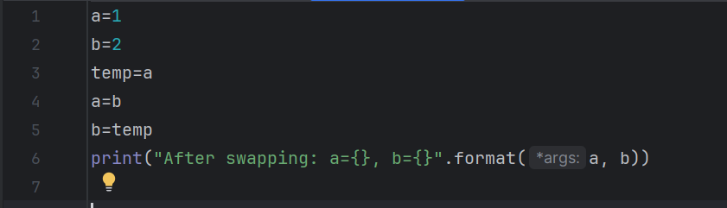

**Output:**

**Task 04:**

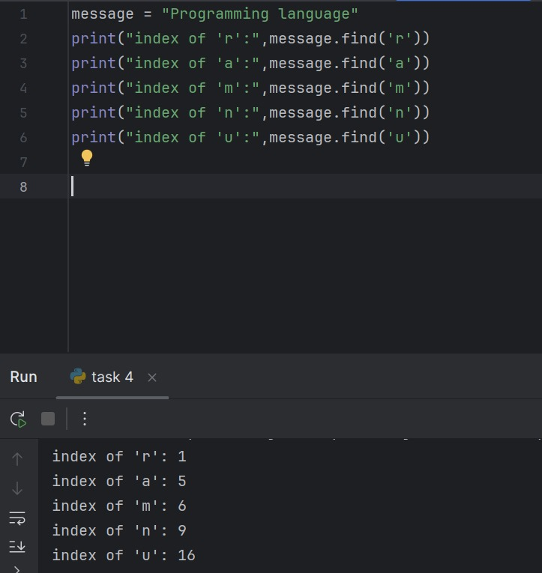

**Output:**



**Task 05:**

